
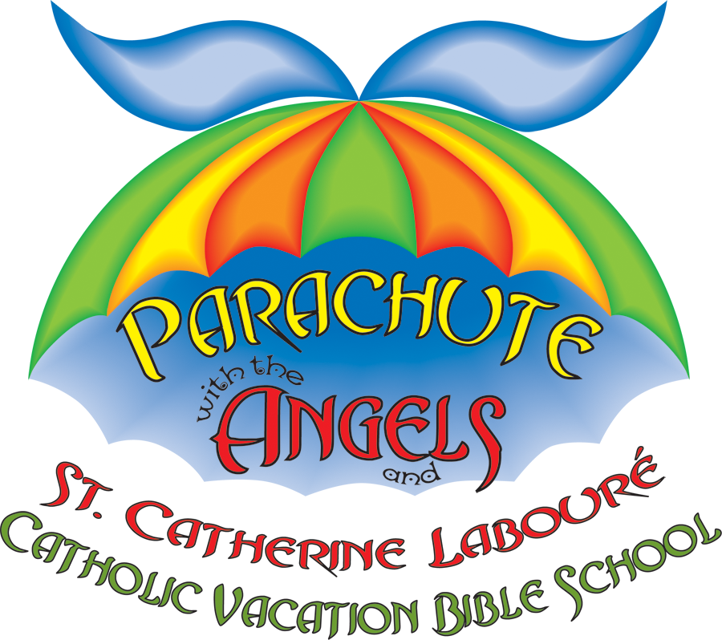
PARENTS!!

GOD IS YOUR PILOT DURING
FUN-FILLED DAYS
OF VACATION BIBLE SCHOOL

Dates: June 2nd – 5th Times: 9 am - Noon
Location: St. John’s Catholic Church
Another NEW and Exciting Catholic VBS
from Growing with the Saints!

Check in with St. Catherine,
pick-up your flightplan
and meet your Co-Pilot:
Your very own Guardian Angel!
Drop in collection or Mail this form to:
St. John the Baptist Catholic Church
4727 McHugh Dr.
Zachary, La. 70791
Or Contact:
Name: Dorothy or Susan
Phone: 654-5885
E-mail: sblackwell@sjb-ola.org

Visit Growing with the Saints at www.growingwiththesaints.com for more Saint Series books for children.
© Growing with the Saints, Inc. - Permission to alter and copy for your program granted.

Child’s Name:
Child’s Name:
Child’s Name:
Parent Name:
Address:
Phone:
City: State: Zip:

K  5-up | Grades  1-2 | Grades  3-4
Can you volunteer to help?
Registration fee per child @ $10 x = $
Reserve my Angel of God Music CD @ 5.99 x = $
Reserve my St. Catherine Labouré Storybook @ 8.99 x = $
I have enclosed a check in the amount of TOTAL $
Register Online: www.sjb-ola.org

POSTAGE

